

Electrical Engineering Student  
University of Wisconsin - Platteville  
woerpela@uwplatt.edu  
920-988-5872

920-9885872

Engineering Design Portfolio

Andrew Woerpel

# Seljan Company Internship

|  |  |
| --- | --- |
| Position: | Mechanical Design Intern |
| Duration: | During College Breaks Summer 2013 – Winter 2015 |
| Group Setting: | Mostly Independent with occasional assistance from upper management and engineers |
| Responsibilities: | Every aspect of projects, from initial design to final implementation |



# Powder Coating Operation

|  |  |
| --- | --- |
| **Approximate Project Cost:** | $50,000 |
| **Project Length:** | 3 months |
| **Period:** | Summer 2013 |

For my first task as an intern at Seljan Company, I was tasked with setting up the infrastructure that would allow them to begin powder coating their products.

Project Details

* Researched process and equipment suppliers
* Obtained equipment quotes
* Presented plan to upper management for approval
* Designed and built steam cleaning booth
* Set up powder suppliers as vendors
* Designed and built powder application carts
* Lead team to assemble powder coating oven and powder application booth
* Attended powder coating seminar in Tennessee with Seljan’s production foreman to better train workers

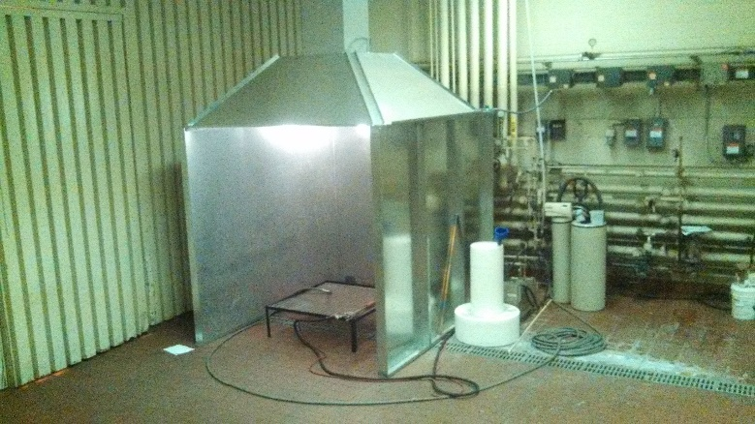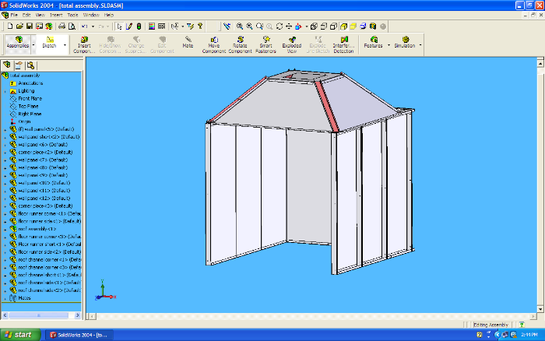

Solid model of steam booth and end result. The square ductwork leading to the ceiling is connected to an existing exhaust fan, for steam removal.

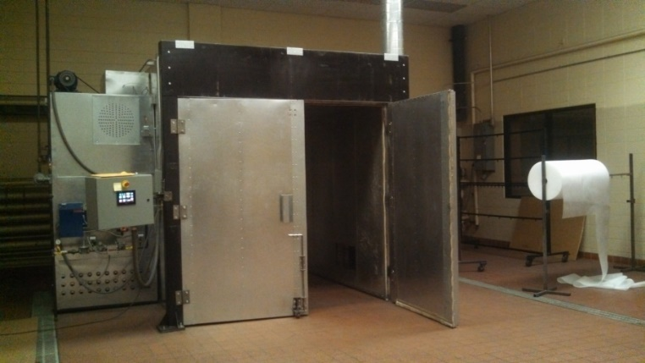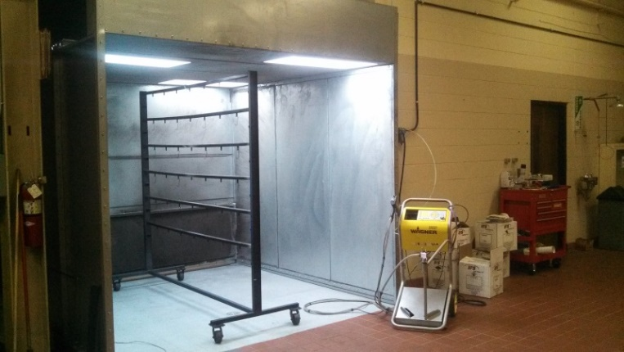

Images showing the 8’x10’x8’ powder coating oven, as well as the powder application booth, powder application gun, and adjustable cart.

# Conveyor System

|  |  |
| --- | --- |
| **Approximate Project Cost:** | $2,500 |
| **Project Length:** | 2 months |
| **Period:** | Summer 2014 |

For my second summer as an intern, I was in charge of creating a system that would remove metal stamping slugs from the back of several large punch presses. Prior to my arrival in the summer, Seljan Company had bought two used industrial quality conveyors, totaling around $5,000, with hopes of using them for this job. It was quickly determined that these were not adequate for this specific job since the slugs would get jammed in the chain drive system, causing the conveyor to stop. Instead of trying to modify these conveyors, I suggested that we build our own and promised that these would work better for this specific job than any commercially available system, and at a fraction of the cost. After some reluctance, I was allowed the opportunity to build a prototype of the conveyors that I had suggested.

Project Details

* Salvaged drive units from used conveyors
* Purchased required components
* Designed two custom conveyors to move slugs into recycling bin
* Assembled final units

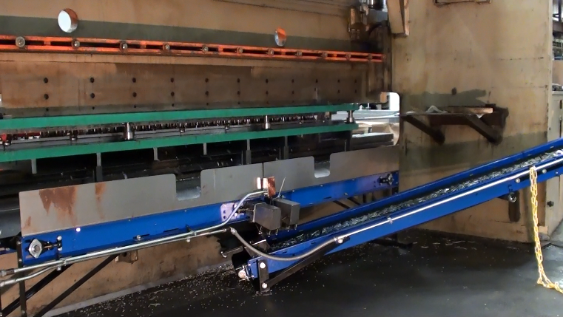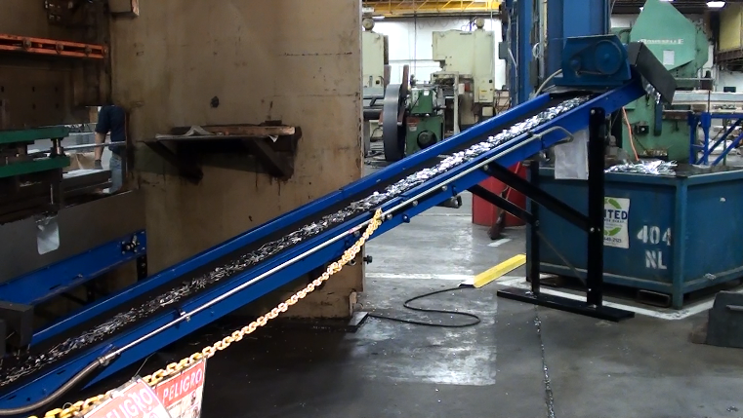

Shows the conveyor system removing slugs from the back of a 300 ton press break. Prior to the creating of this system, the slugs fell on the floor and were removed using scoop shovels.

Project Highlights

* Have been running almost continuously for 6 months without breaking down
* Have moved approximately 60 tons of slugs

# Pallet Construction Operation

|  |  |
| --- | --- |
| **Project Length:** | 3 weeks |
| **Period:** | Winter 2013 |

Seljan Company had recently began producing specific parts in such volume that the cost of purchasing pallets from a supplier was becoming quite expensive. Therefore, over winter break I was tasked with creating a process and the equipment necessary to construct these specific pallets. I designed and built an adjustable assembly fixture, a saw table with easily adjustable end stop, and saw horses for this project.

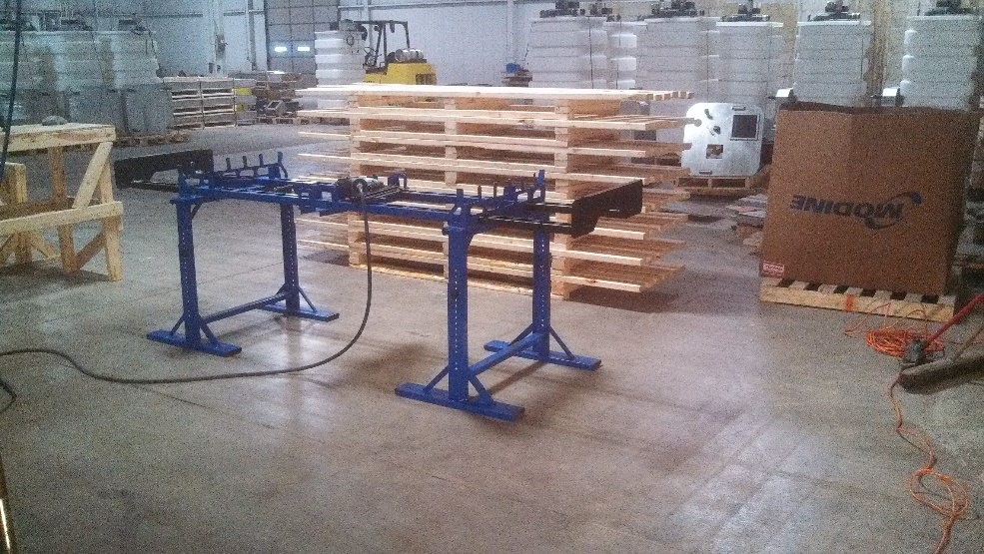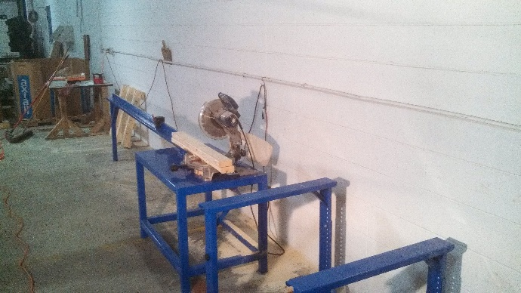

Shows the pallet assembly fixture and finished pallets, as well as the lumber sawing station.

# https://scontent-a-ord.xx.fbcdn.net/hphotos-xaf1/t31.0-8/10669307_257533657704264_7599204323201149302_o.jpgSociety of Automotive Engineers (SAE), Aero Design Team

|  |  |
| --- | --- |
| Position: | Electrical Engineer |
| Duration: | Fall 2014 - Present |
| Group Setting: | Work as a team with freshman EE student |
| Responsibilities: | Project management, communication with team, hardware/software design and construction |

The recently created Aero team at UW – Platteville did not have any members who were Electrical Engineers students until myself and another student joined the team. Because of this, the power system for their previous plane was not utilized to its full potential. Furthermore, the motor/propeller test stand that they were using had a large amount of parasitic friction, lacked the ability to produce consistent tests, and required handwritten data collection. It was our goal to greatly improve this system by completely redesigning the stand and automating the testing process.

# Motor/Propeller Test Stand

|  |  |
| --- | --- |
| **Project Length:** | Ongoing |

Project Contributions

* Designed and built test stand
* Designed circuitry that allows a Teensy 3.1 microcontroller to measure
  + Current
  + Voltage
  + Thrust
  + RPM
* Wrote program in Python to
  + Check battery voltage to ensure battery is not over drained
  + Zero out current sensor and strain gauge readings
  + Request and obtain ADC values from microcontroller
  + Scale ADC values
  + Create test profile based on power consumption
  + Control throttle of test stand based on reference power profile and instantaneous power consumption
  + Create a .txt file with measured values for future analysis
  + Display graphs with test results

Shows the test stand (powder coated UW – Platteville colors) and the strain gauge used to measure thrust.

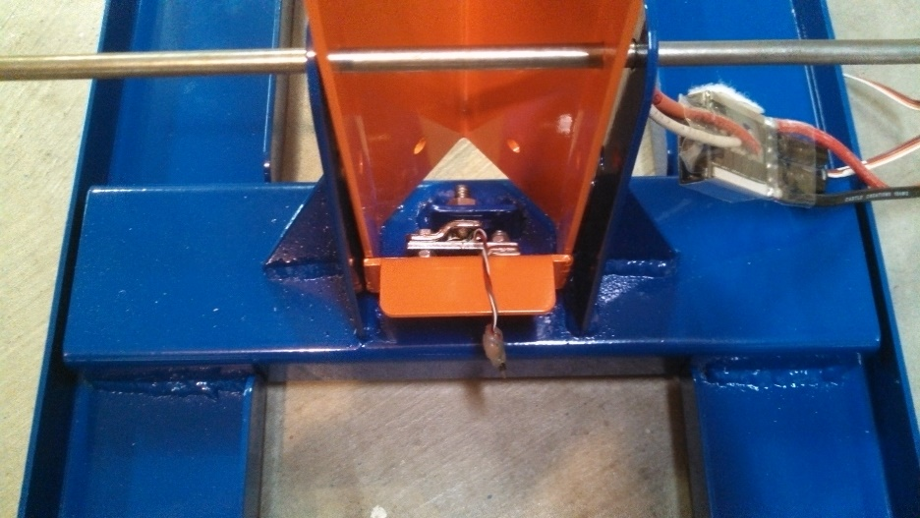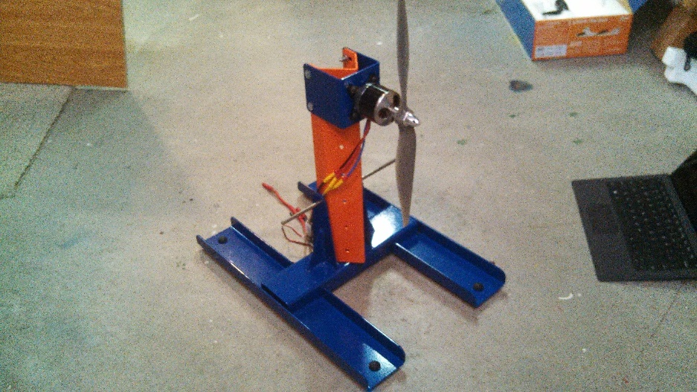

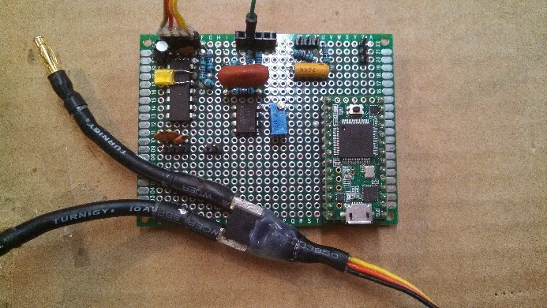The aspect of this project that I am most proud of is the throttle controller that I built in software. Competition rules place the maximum power that the electrical system can consume at 1000 W, and require that each team install a power limiter in their plane that shuts off the motor in the event that the plane goes over this limit. For this reason, it will be very valuable to have a controller that will manage the throttle of the motor based on the desired power consumption of the system. A similar controller will be implemented in the competition plane to ensure that the maximum allowable power is being consumed, without fear of exceeding the competition limit. The team feels that the power system improvements along with a larger aspect ratio wing will allow us to best the fourth-place finish that was achieved last year.

Shows the data acquisition circuitry and microcontroller.

**See Appendix for an example power and thrust graph**